25 May 2007 The Weekly Bulletin of Rotary Club of Kathmandu Mid-Town Bc # 47 of 2006-07
Rotary Club of Kathmandu Mid-Town
Breakfast Chatter




District : 3290 Web: www.rotarymidtown.org.np Club Id : 26776

MAY IS THE DISTRICT MONTH
District Assembly: The purpose of this one-day seminar, held in April or May, is to prepare incoming Rotary club leaders for their roles.
The following topics are included in the district assembly for each group par-ticipating in the training:
• Roles and Responsibilities; • Guiding Principles — Policies and Procedures;
• Selecting and Training Your Team; • Developing a Plan of Action;
• Resources; • Review of Successful Stories
• Practical Application: Building a Plan; • Problem Solving
The participants in the district assembly shall be club presidents-elect and the members of Rotary clubs assigned by the club president-elect to serve in key leadership roles in the upcoming Rotary year.
Where circumstances require, if the district conference is held during April or May, consideration may be given to holding the district assembly and the district conference as consecutive meetings, provided that in scheduling the meetings the district conference is held second. Such consecutive meetings should be scheduled without reducing the time required for each and with due regard for the essential features of each.
RI provides a standard curriculum including facilitators’ guides, visual aids, and participants’ manuals to support the district assembly.

Rtn Er Murali G Ranjitkar, shared his agony and nightmare while he was abducted along with other three
by JTMM-Goit on Friday 11 May and released on Sunday 13 May
at the Club meeting on Friday, 18 May 2007.
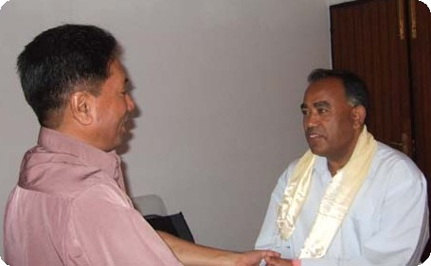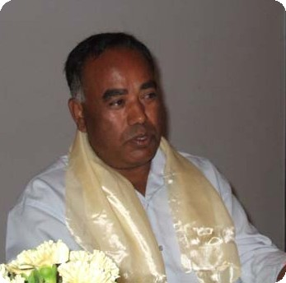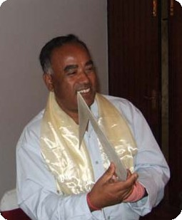
(a) Rtn Er Ranjitkar being provided a khata by Actg President Subarna Joshi to welcome him to the Club
(b) Guest speaker Murali sharing his agony, moments of torment and torture during his abduction, and
(c) Rtn Murali G Ranjitkar, after accepting a Best Wishes Card, thanking the Club members.

Weekly Meetings and Programs :
Date | Program/Speaker | Program/Topics of Presentation
25 May 2007 | SSP Basant Kunwar | Drugs as dangerous traps for Nepal
1 June 2007 | Joint meeting | Joint meeting with RC Rajdhani
8 June | Dinner meeting

Friday, 25 May :
SSP Basanta R Kunwar, Chief of crime prevention in CI Department, Police Headquarters, will be talking on drug addiction, a danger trap for Nepali youth. His discussions will cover drug addiction in general, identifying addicts, consequences in families and educational institutions, role of communities etc.
Mr Kunwar, as an expert in the area of drugs abuse management and human traffiking issues, is the founder of three drug rehabilitation centres, including Narconon Nepal, and is involved actively in protecting school children from drug addiction.
He is the Executive Director of Pratigya, Narconon Nepal.

District Assembly :
Rotary District 3290 cordially invites all Rotarians for participation in District Assembly on Saturday, 26 May 2007 at Park Village Hotel & Resort, Budhanilkantha, Kathmandu at 08:00 hrs.
Registration : Rs 700 per person to cover breakfast and lunch.
District Award Ceremony :
Date: Saturday, 26 May 2007; Venue: Hotel Radisson, Lazimpat; Time: 17:30 hrs.
Registration: Rs 700 per person for cocktails and dinner.

Five-star hotel for your pets !
Japanese pet owners can now embark on their foreign travels safe in the knowledge that their pampered pooches and moggies will be living in the lap of luxury at a five-star 'pet hotel' that is opened at Tokyo's Narita airport. The Pet Inn Royal boasts 170 well-appointed rooms for up to 250 animals, as well as veterinary and grooming services, field and staff to see to their 4-legged guests' every need 24 hours a day. All rooms are fitted with air conditioning and purifiers to leave them smelling sweet for the next occupant.
Source: The Himalayan Times

On Lighter Side : Click at the figure ⇩


I have always been proud to be a Rotarian, but as I see more and more of what Rotary can accomplish, I am ever more honored to be a member of the first and the greatest service club in the world.
RI President William B. Boyd

25 May 2007 The Weekly Bulletin of Rotary Club of Kathmandu Mid-Town Bc # 47 of 2006-07

Editor: RR Shrestha, Club Service Director email: rryes@wlink.com.np

